**RICE**

**HERO**



Rice is a staple grain consumed globally in countless forms, from everyday meals to specialty products. Flexicon bulk material handling systems are built to handle rice with precision, ensuring smooth conveying, reliable storage, and gentle processing from start to finish.

**Button**: Talk To Us

**SHELF #1 - PRODUCT DESCRIPTION**

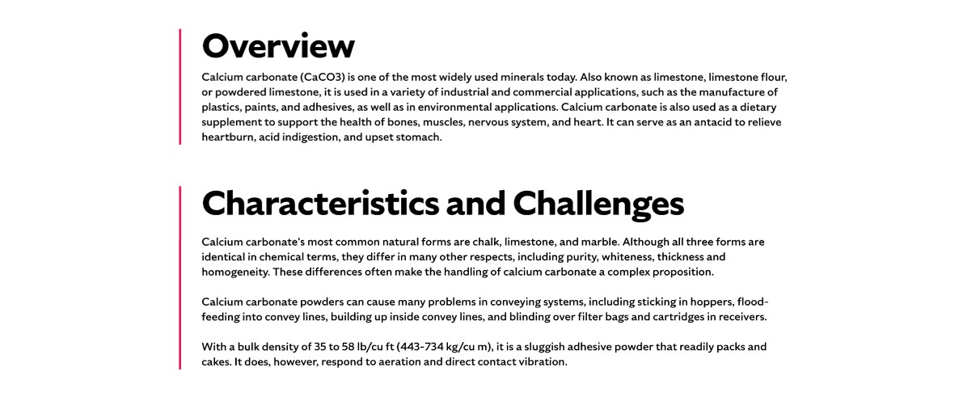

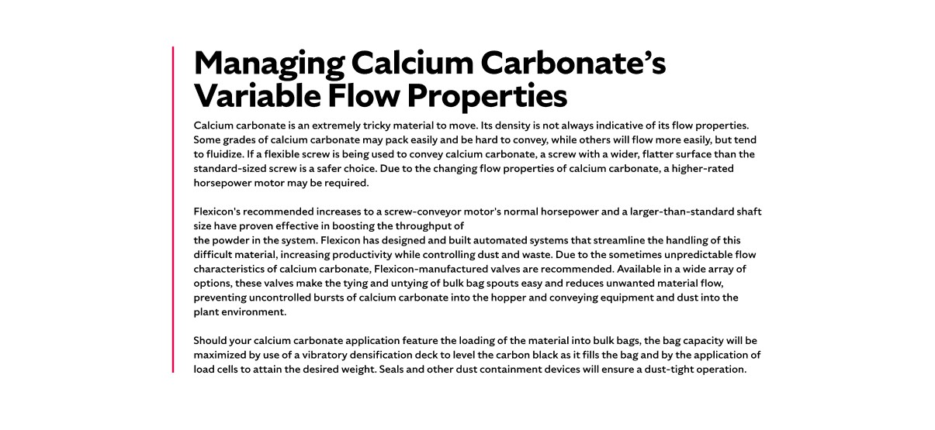

**Overview**Rice is the seed of a swamp grass and ranks among the most widely cultivated crops for human consumption worldwide. It is used in a variety of food products including entrees, cereals, desserts, and even beverages like sake. With over 40,000 varieties classified as long grain, medium grain, or short grain, rice processing involves multiple steps such as husk removal, milling, and polishing. Flexicon systems support these processes by ensuring clean, consistent, and damage-free handling of rice from bulk delivery to final packaging.

**Characteristics and Challenges**Rice is a free-flowing, granular material with a typical bulk density of 45 lb/cu ft and may be mildly abrasive. When pneumatically conveyed, the system’s blower must be properly sized to maintain an air-line velocity that avoids damaging the rice, which can be degradable. Bulk bag dischargers should include accessories that reduce manual effort, such as bag elongation devices that promote better flow and eliminate trapped pockets of rice. These devices also help form a dust-tight seal between the bulk bag and receiving hopper, preventing airborne particles from escaping as displaced air exits the hopper. A dust collector mounted on the discharger frame further contains dust, improving sanitation and reducing cleaning time in food processing environments.

Feed hoppers should be designed with proper geometry and may require flow-promoting devices like vibrators. For rice packaged in smaller bags, bag dump stations with dust hoods and filtration systems support manual unloading while maintaining a clean workspace. Integrated bag compactors allow operators to dispose of empty bags in a dust-contained manner, and hopper screens help prevent foreign objects from entering the system. When using flexible screw conveyors, a round screw is typically recommended for conveying rice up an incline. Additional safety measures, such as magnets and metal detectors, can be used to remove tramp metal during processing. For bulk bag filling applications, vibratory densification decks and load cells help maximize bag capacity and achieve precise weight targets, while seals and dust containment devices ensure a clean, dust-tight operation.

**SHELF #2 - FLEXICON SOLUTIONS**

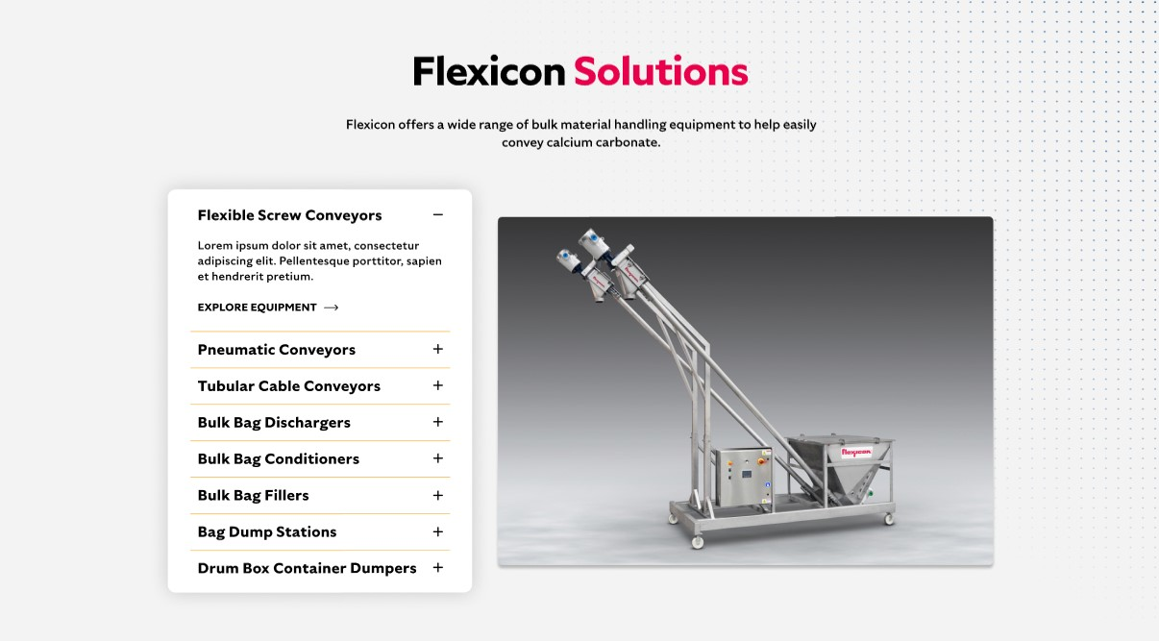

**Flexicon Solutions**

Flexicon offers a wide range of bulk material handling equipment to help easily convey rice.

**Flexible Screw Conveyors:** Gently convey rice without degradation or separation, maintaining product integrity throughout the transfer process.

**Pneumatic Conveyors:** Enclosed systems efficiently move rice while containing dust and preserving grain quality for a clean and safe operation.

**Tubular Cable Conveyors:** Provide flexible routing through tight spaces with enclosed handling that minimizes product damage and contamination.

**Bulk Bag Dischargers:** Safely unload rice from bulk bags into downstream systems with spout locking and dust-tight features for controlled flow.

**Bulk Bag Conditioners:** Loosen compacted rice in bulk bags to promote consistent discharge and prevent flow interruptions.

**Bulk Bag Fillers:** Accurately fill rice into bulk bags using densification decks and load cell controls to minimize dust and ensure target weight.

**Bag Dump Stations:** Support manual dumping of rice with integrated dust collection systems for cleaner, safer work environments.

**Drum/Box/Container Dumpers:** Transfer rice from smaller containers into processing systems while reducing dust escape and manual handling risks.

**SHELF #3: LIFETIME PERFORMANCE GUARANTEE**

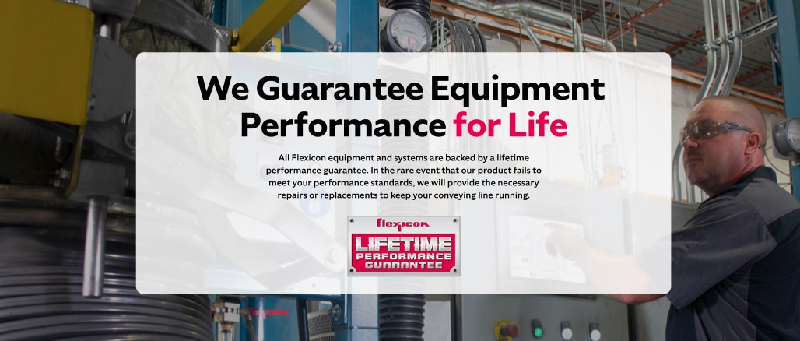

**Lifetime Performance Guarantee**

All Flexicon equipment and systems are backed by a lifetime performance guarantee. In the rare event that our product fails to meet your performance standards, we will provide the necessary repairs or replacements to keep your conveying line running.

**SHELF #4: CASE STUDIES**

